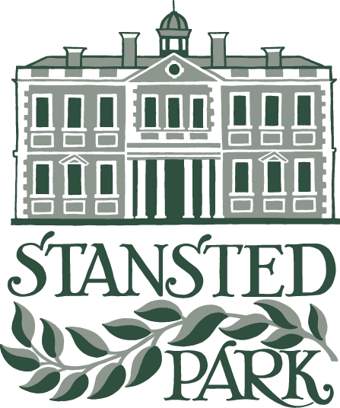

Rowlands Castle, Hampshire, PO9 6DX

Charity Gift Aid Declaration – single donation

Boost your donation by 25p of Gift Aid for every £1 you donate
Gift Aid is reclaimed by the charity from the tax you pay for the current tax year. Your address is needed to identify you as a current UK taxpayer.
In order to Gift Aid your donation you must tick the box below:

I want to Gift Aid my donation of £______________ to:

Name of Charity: STANSTED PARK FOUNDATION
I am a UK taxpayer and understand that if I pay less Income Tax and/or Capital Gains Tax in the current tax year than the amount of Gift Aid claimed on all my donations it is my responsibility to pay any difference.

My Details

Title ____________________ First name or initial(s) ________________________________

Surname _____________________________________________________________________

Full Home address _____________________________________________________________

_____________________________________________________________________________

Postcode _________________________ Date ___________________________________

Please notify the charity if you:
- want to cancel this declaration
- change your name or home address
- no longer pay sufficient tax on your income and/or capital gains

If you pay Income Tax at the higher or additional rate and want to receive the additional tax relief due to you, you must include all your Gift Aid donations on your Self-Assessment tax return or ask HM Revenue and Customs to adjust your tax code.

